Basics of Studio Lighting
There are 3 main things to consider: Size of light source, intensity of light, and position of the light source.

Size of light source
- The larger the light source, the softer the light. This means shadows will be less harshly delineated
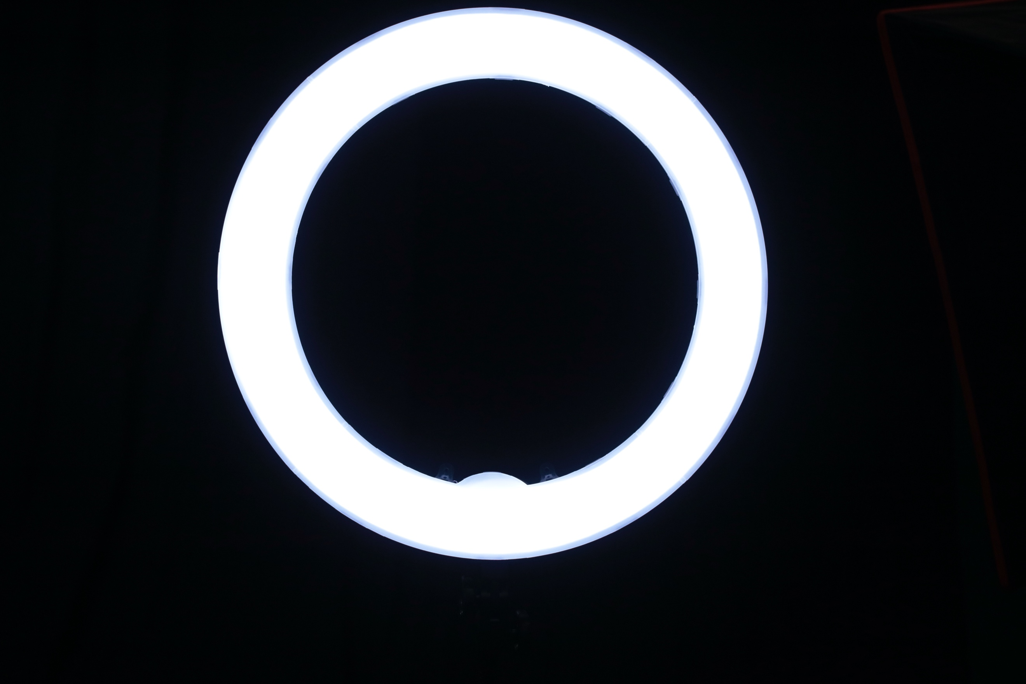
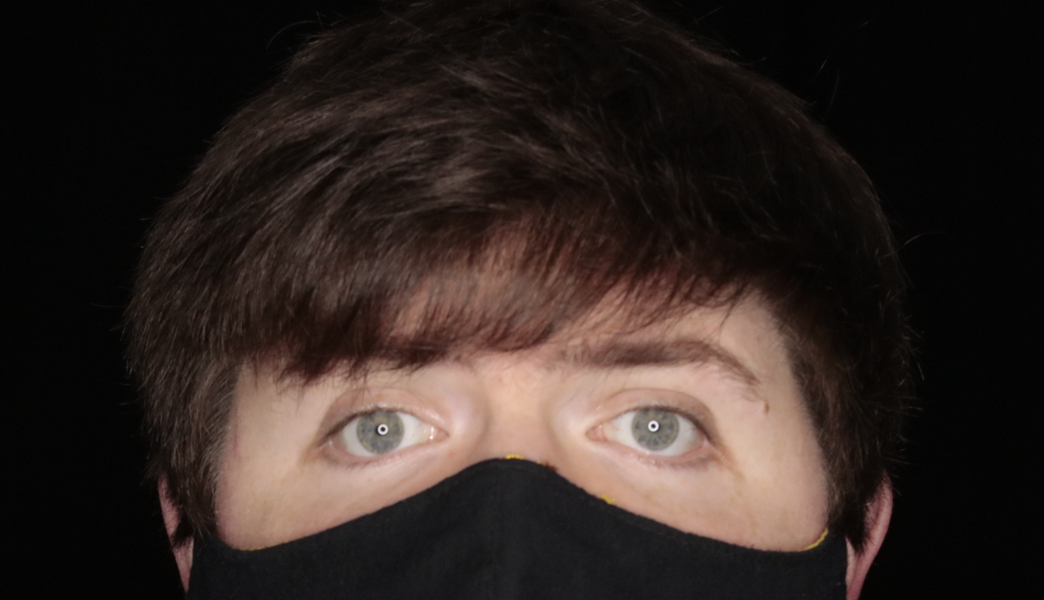
- The DMC Photo/Video Studio offers a ring light and LED lights with diffuser dome, small softbox, and large softbox attachments

  - The ring light provides soft, even lighting by mimicking a light with the same diameter as the ring, with the caveat of providing ring shaped highlights in the eyes which some people do not care for

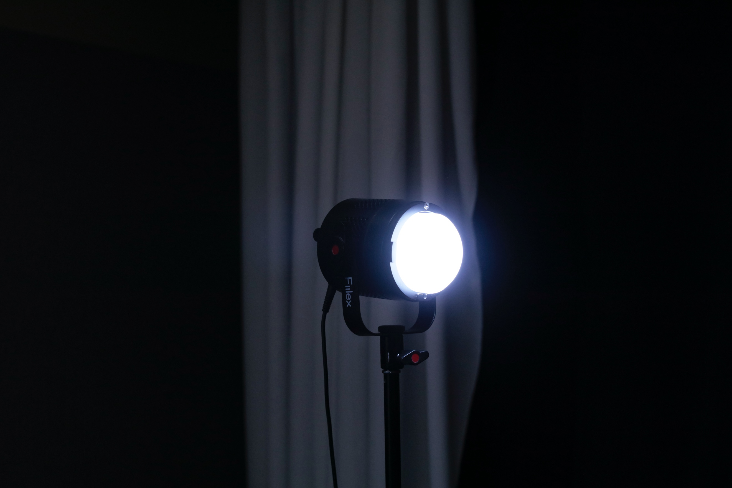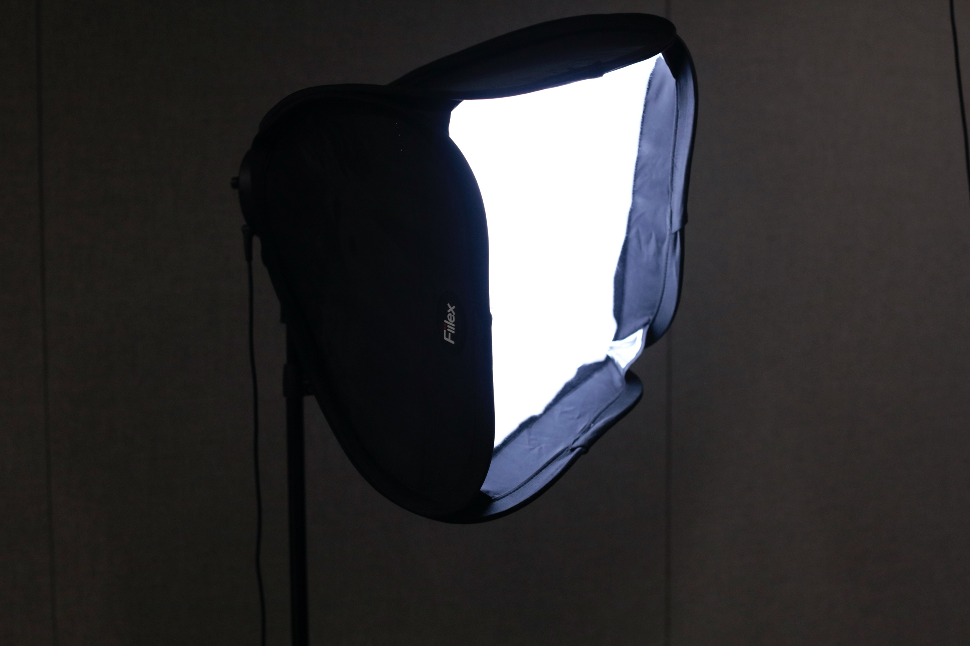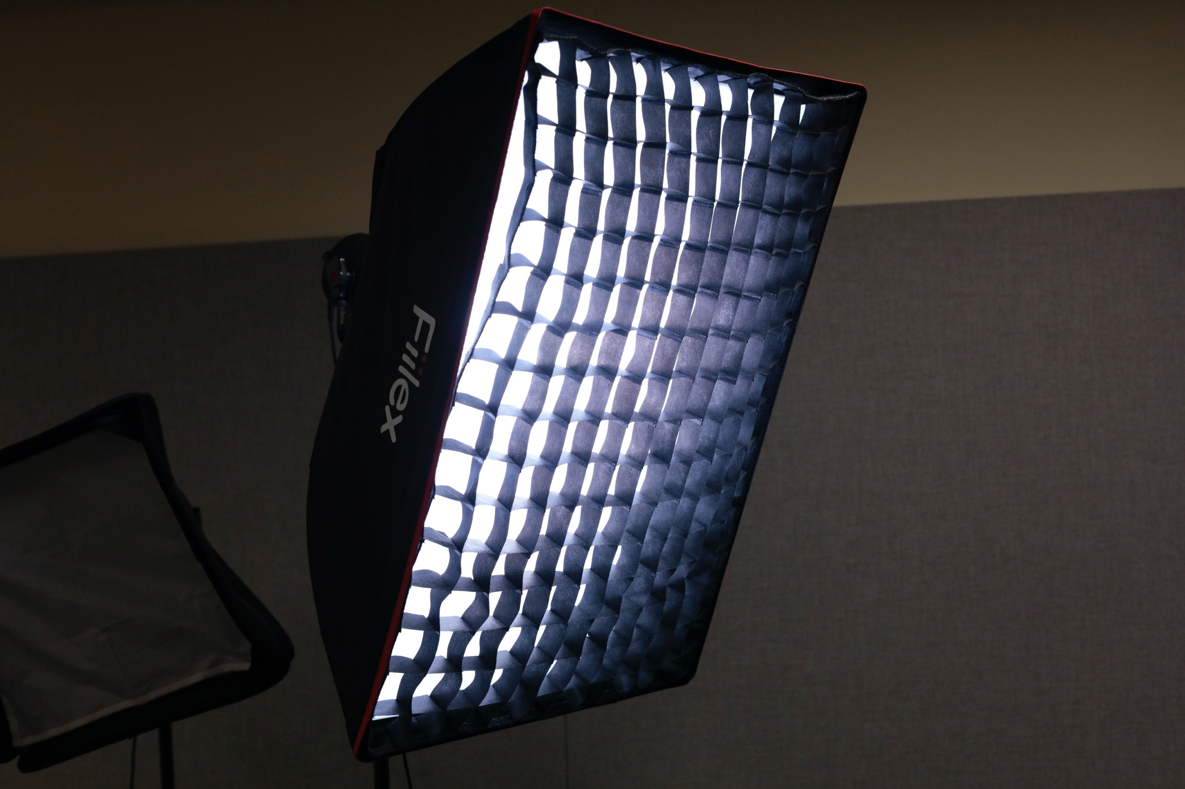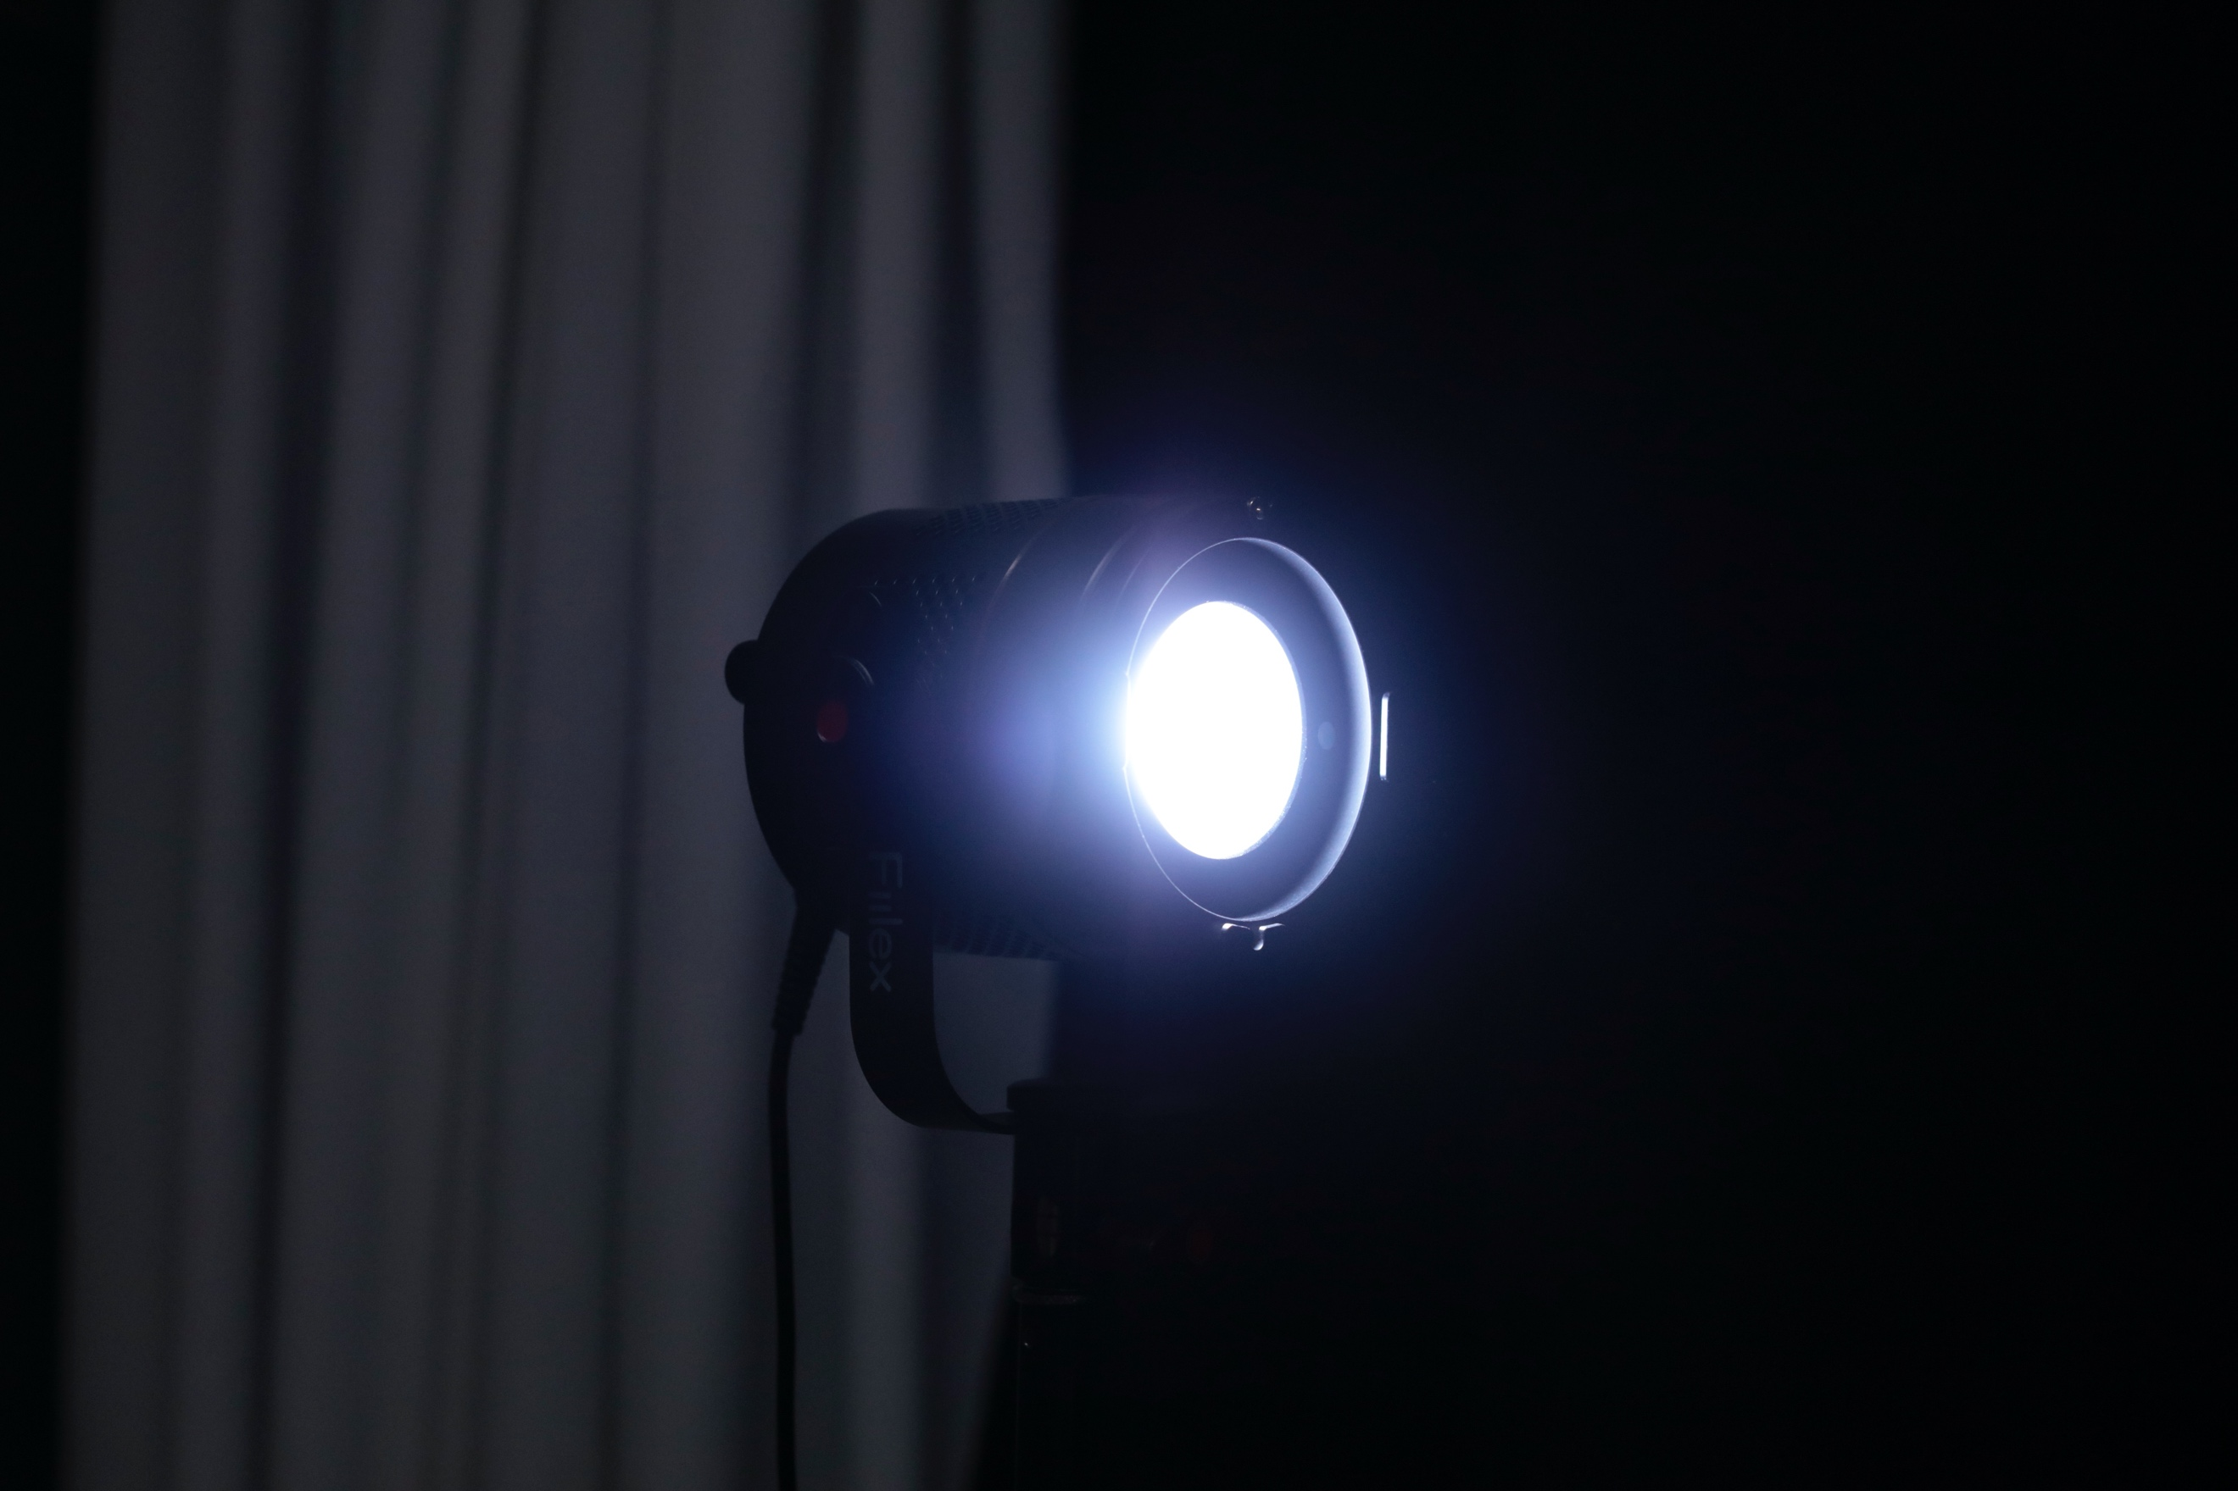
  - The LED lights can be set up with either the diffuser dome for the harshest light, small softbox for somewhat softer light, or large softbox for the softest light available in the studio
    - The Large softbox also comes with a detachable grid, which allows you to direct the light at your subject without having it spill over to the backdrop
  - In the event that you want crisp delineation between light and shadow, the LED lights can be used without the diffuser domes

Position of Light
- Most lighting setups rely on lights positioned at a 45-degree angle to the subject. This allows for some shadows on the subject’s face, without being overly dramatic.
- If the light is positioned level to the subject (i.e. at the same height), the shadows will be a bit deeper than if it is placed higher than the subject and angled down towards them
- For distance to the subject, you ideally want to position the lights as close to the subject as you can without getting them in the shot
- The ring light can be positioned directly in front of the subject for flat even lighting, which may be useful for some applications with architectural models or portraits
- Refer to the lighting guide on the wall for guidance on common lighting setups. Note that many lighting setups use a secondary light positioned at an opposite angle from the first light to fill the shadows some.

Intensity of Light
- Put very simply, all of our lights have adjustable intensity. Your primary light source should always be set to the highest intensity, with secondary light sources set lower. If they are set to the same intensity, you will flatten out all of the shadows, which may be what you want, but typically some contrast between light and dark is desired
- Distance from the subject also affects intensity of light. The farther a light source is from the subject, the less intense the light on the subject will be
- Diffusion materials will also slightly decrease the intensity of the light

