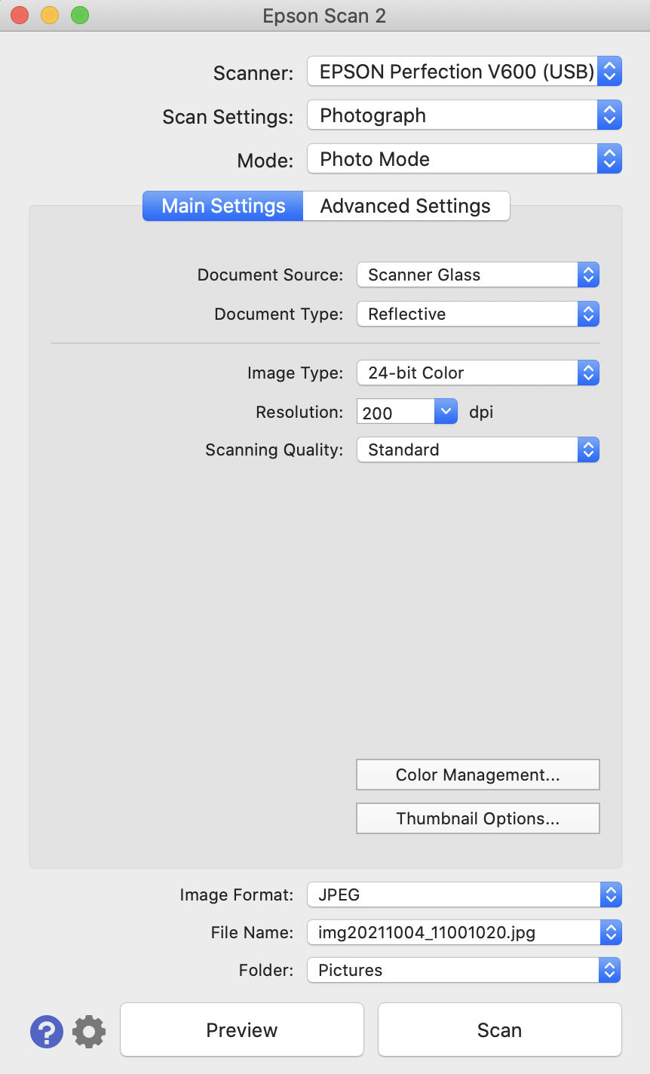
Station 12 - Using the Epson Perfection V700
Scanning Images/Photos
- Make sure the Epson scanner is turned on. The power button can be located on the bottom left corner in front of the machine.
- Lift the cover of the scanner and place your document face down on the glass. Make sure to align the top right corner of your document to the aligning point.
- Click the EPSON Scan 2 icon in the dock.
- Double-check these settings. Pay special attention to the resolution option:
  - Mode - Photo Mode
  - Document Type - Reflective
  - Image Type - 24-bit Color (16-bit Grayscale if you want black and white)
  - Resolution - For a photo to be used in PowerPoint or Web, use 200dpi. For a photo for archival purposes or book publications, use 300dpi.
- Double check these settings:
  - Folder – Other: SAVEWORKHERE
  - Image Format – For a photo to be used in PowerPoint or Web, use JPEG. For a photo for archival purposes or book publications, use TIFF.
- Click Preview to see image before scanning. If you wish to scan only part of the photo, drag your cursor to create a selection box around the area you want.
- Click Scan.

