INTRODUCTION TO
ADOBE
LIGHTROOM

What To Expect:

1 – Differences between Photoshop and Lightroom

2 – Importing Photos

3 – The Develop Tab

4 – Histogram and Basic Menu

5 – Lightroom Specific Tools

6 - Exporting

Differences between Photoshop and Lightroom:

Photoshop
- Allows for extreme manipulation of every single detail within a photo
- Uses layers to be able to delete, add, merge, or stack different images together

Lightroom
- Serves as both a photo editor and organizer with libraries, catalogs, and locations
- Can be used for scrapbooking or slideshows
- Import, view, and edit multiple photos on a single window
- Only works with a single layer, meaning no additional pixels can be added

Importing Photos:

- Connect USB cable, insert SD card, or select “File” -> “Import Photos and Video…”

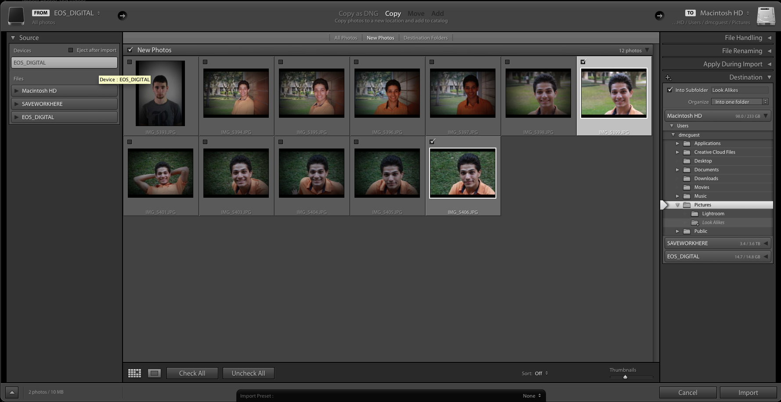

- Check mark desired photos. Create a folder.

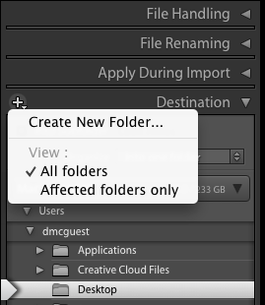
The Develop Tab:
- Select the Develop tab from the banner

- The photo strip on the bottom displays all the photos in that particular folder

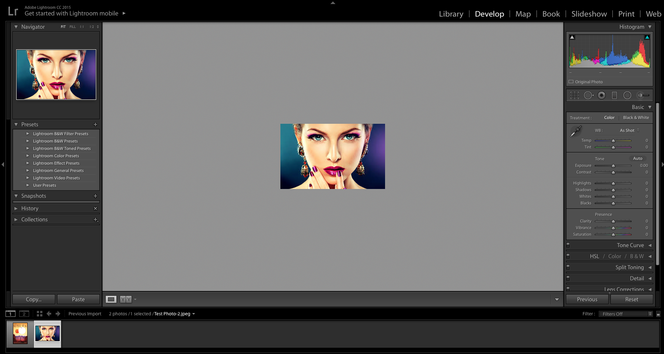

- The Before and After selection is one of the most important features of the Develop tab

Histogram and Basic Menu:

- To open a menu, click the triangle. We will be focusing on Histogram, Basic, and one feature in Effects
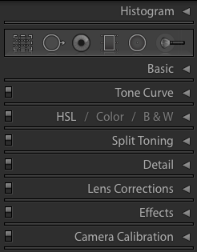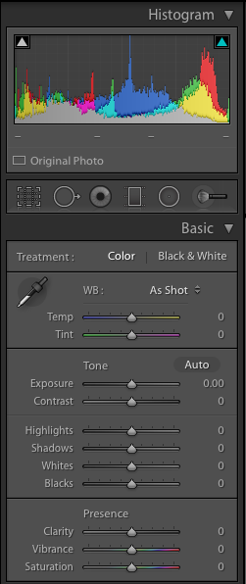

- Treatment determines color or B&W. White balance controls the temperature of the photo – cool or warm

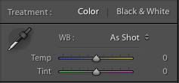

- Exposure changes the overall brightness. Contrast increases or reduces the overall range and distance between brights and darks

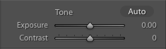

- Highlights affect the mid to high range of pixels.
Shadows affect the mid to low range of pixels. Both are used to recover detail
- Whites affect the extreme high range.
Blacks affect the extreme low range. These help to define “true” white and black in an image and subtly increase contrast

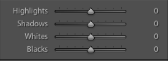

- Clarity improves sharpness and detail.
Vibrance intelligently affects color
Saturation boosts across the entire color spectrum. Both should be used gently

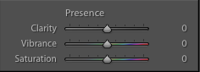

- In Effects, Amount gives you a vignette, and Grain Amount gives you image noise
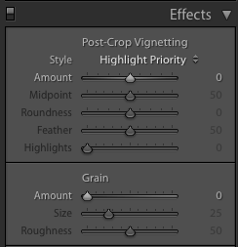

PRO TIPS
- Double-click the word of any of the sliders and it will reset that parameter to zero
- For “whites” and “blacks”, click on the slider and then press and hold the option key. You will now only be able to see the pixels being affected. Generally, manipulate the sliders until only a few pixels in each extreme are showing
- Unless going for extreme looks, use the vibrance tool to boost or reduce general color saturation. It won’t affect skin tones as much and provides a more natural feel
- Don’t be afraid to pull the sliders all the way to one side just to see what happens
Lightroom Specific Tools:
- Crop Tool resizes your image. You can also rotate your image with angle

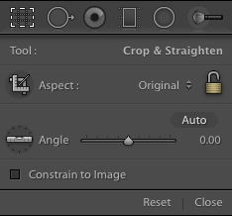

- Heal Tool is used to remove blemishes by attempting to replace pixels with a similar section in the image

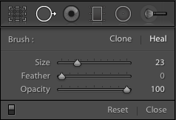
- Red Eye Tool removes the harsh red light in the pupils sometimes caused by flash

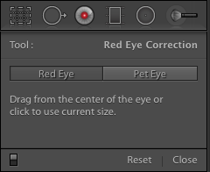

PRO TIPS
- If possible, try to frame your photo to avoid cropping as much as possible in post-processing. Extreme cropping reduces the quality of your image because it enlarges the remaining pixels
- The Heal Tool is most useful for facial blemishes, but can be used to remove other smaller objects. If you are unsatisfied with the replacement, you can manually move the healing circle for more control

- Gradient Tool affects the part of the image highlighted within the initial rectangle before fading away through the mid way point. It works in a click and drag fashion

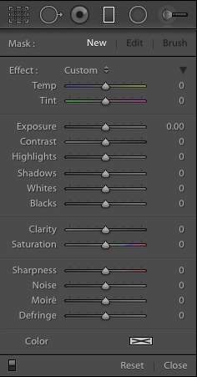

- Radial Tool applies edits to circular or oval shaped region. It can be set to affect what is inside or outside of the selection

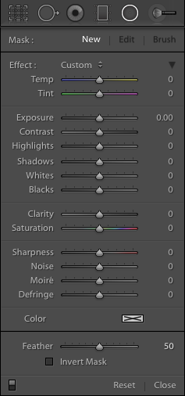

- Healing Brush allows you to draw your selection on the image before editing just that region
- Feather determines how hazy the edge of the edits are
- Flow determines how strongly the selection is painted on with pass of the brush. In this way, you can have the edits affect one portion stronger than the other

PRO TIP
- Press “O” to see exactly where your selection is in red
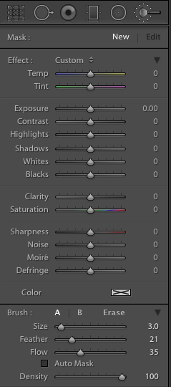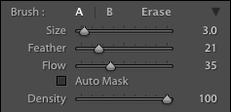
Exporting:
- Choose the folder you wish to be the destination for your images after exporting

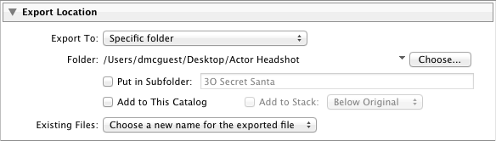

- Sequence your images if you want sequential numbers after the name of your files. Otherwise, select one of the other naming options

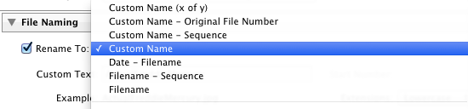

- JPEG and TIFF are most common. Keep Quality at 100, and then select Resolution depending on your image size needs.

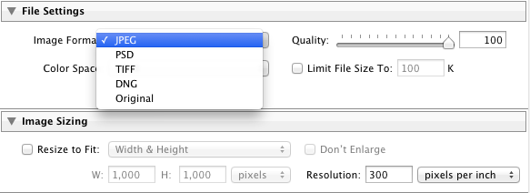

- Watermarking allows you to “sign” your images. Edit Watermarks… lets you upload your signature or company

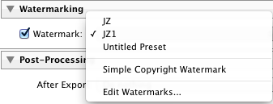

- Finally, let Lightroom know what you want to do afterwards.

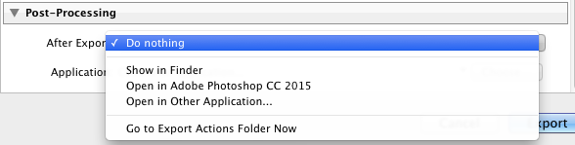

Additional Notes:

Enjoy Lightroom! If you have further questions, you can e-mail me at jsc5@rice.edu

