Recording Music Performance or Interviews Using Zoom H4n

The Digital Media Commons

Fondren B42

http://dmc.rice.edu/

dmc-info@rice.edu

(713) 348-3635

Select the built-in mics to record.
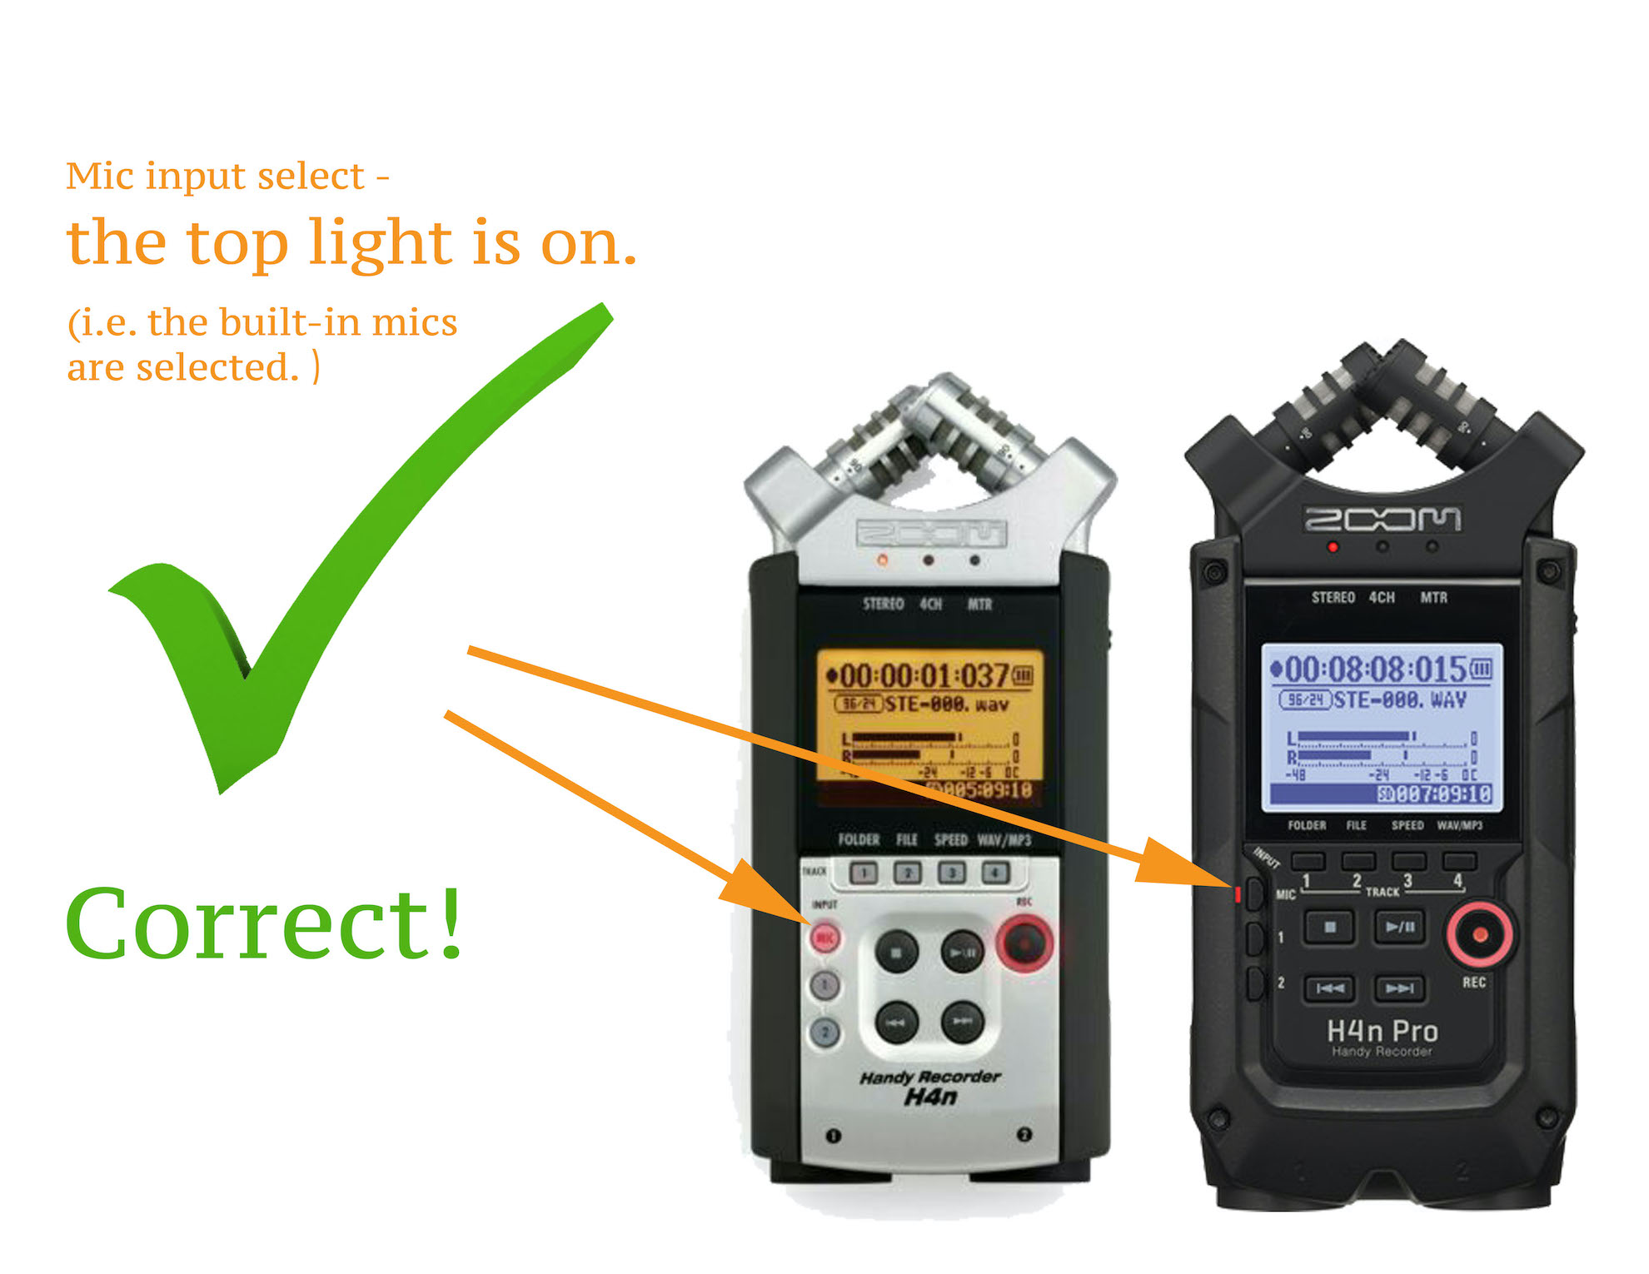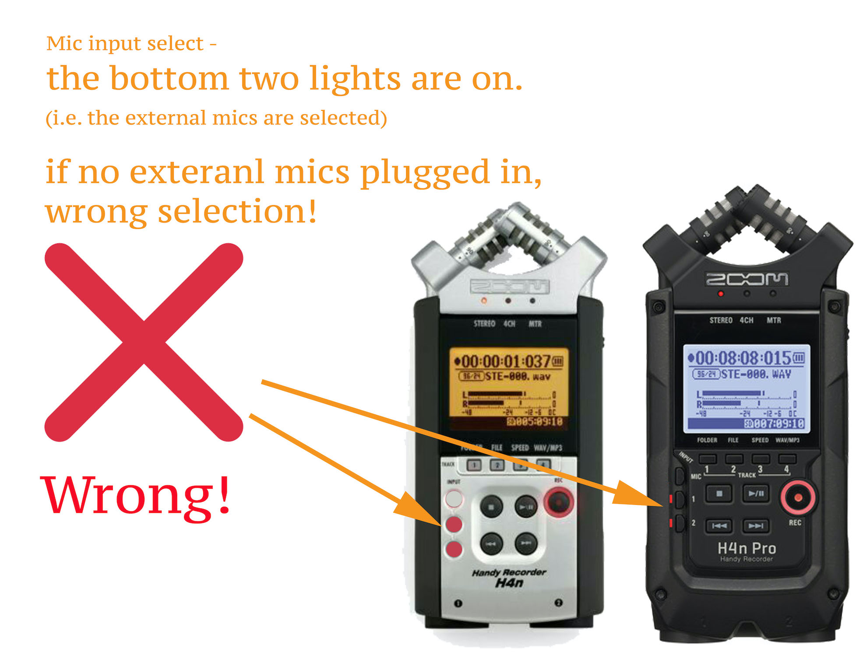

Overview of Zoom H4n
  - Recording Mode:

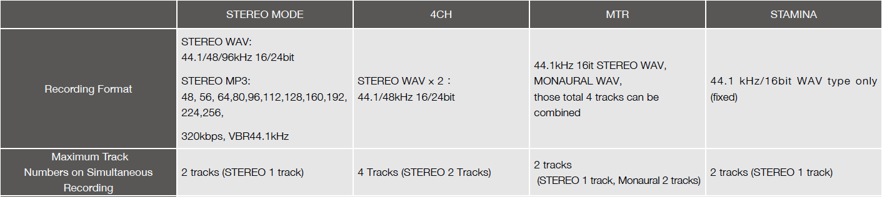
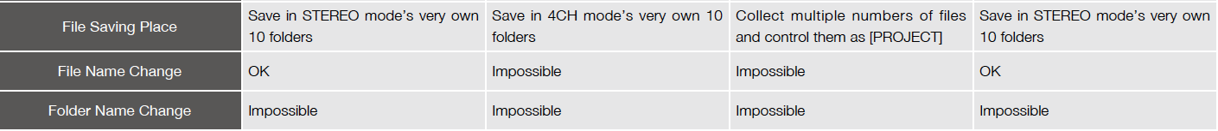
(Figure from H4N Operational Manual pg.137)

  - Recordable times on a 4GB SD card in Stereo Mode

Data format | Maximum recording time
Wav (24-bit/96kHz) | 2 hours
Wav (16-bit/48 kHz) | 5.5 hours
Wav (24-bit/44.1 kHz) | 4 hours
Wav (16-bit/44.1 kHz) | 6 hours
MP3, 128 kbps | 68 hours

  - Battery life: continuous recording up to 6 hours in WAV 44.1 kHz, 16bit settings.

  - H4n names of parts:

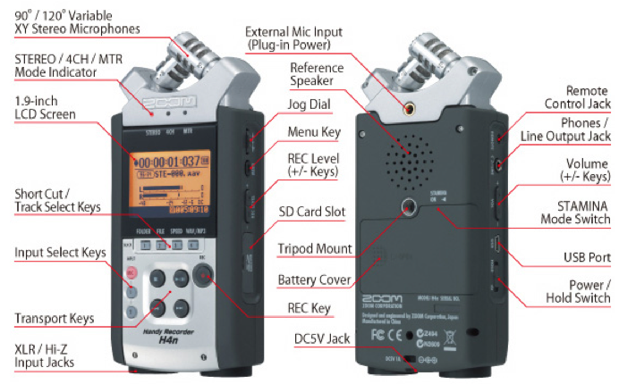

2. Basic Operations in STEREO MODE
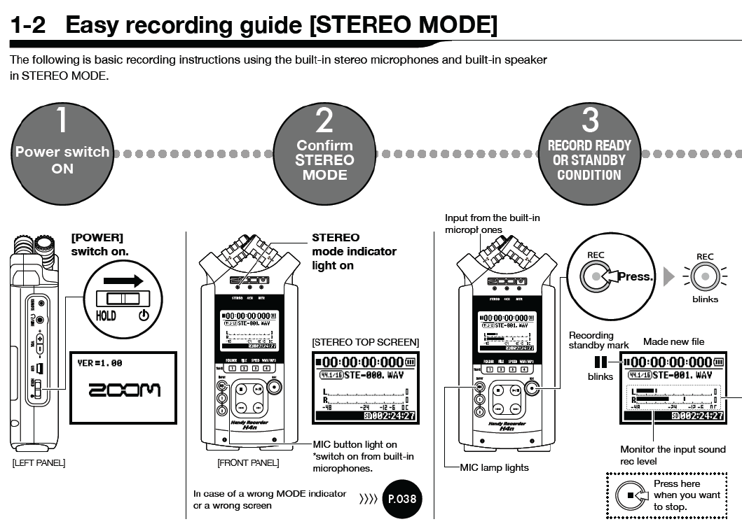
Make sure this light is on indicating you are using the built-in mics.
(Figure from H4N Operational Manual pg.11)

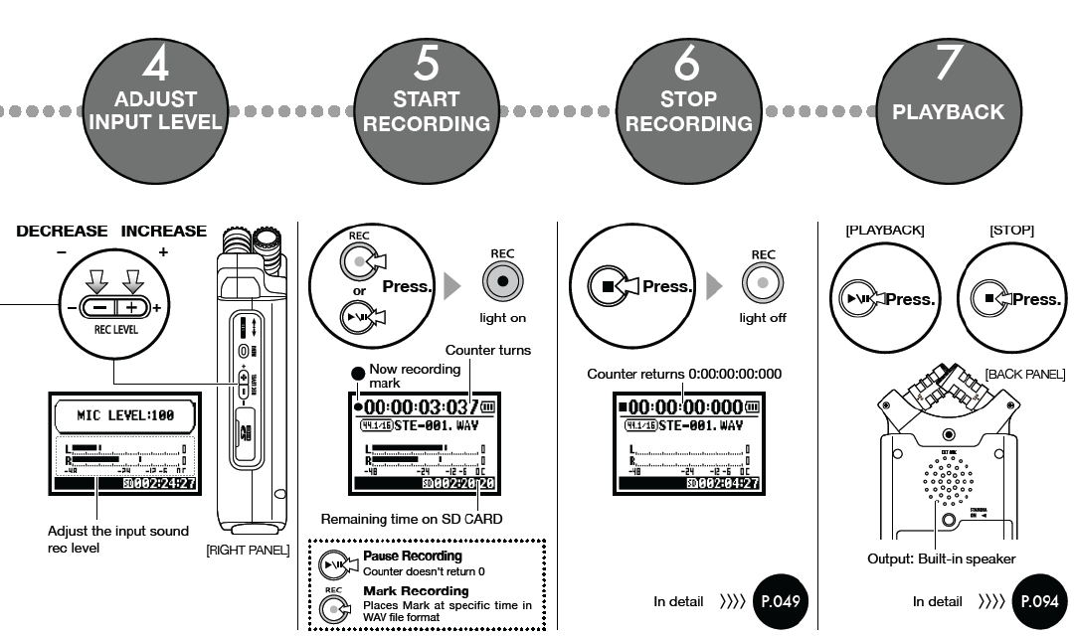

(Figure from H4N Operational Manual pg.12)

- Setting Recording Mode: STEREO, 4CH, MTR (multi-track mode): (Check this video on YouTube at http://youtu.be/iUf-a1Yyxnc for a brief introduction to each recording format)
  - Turn on the power located on the left side of recorder.
  - Press MENU button located on the right side of recorder.
  - Rotate the DIAL, and the cursor on the display will move along the DIAL until MODE is highlighted.
  - Press down DIAL to enter recording mode select screen.
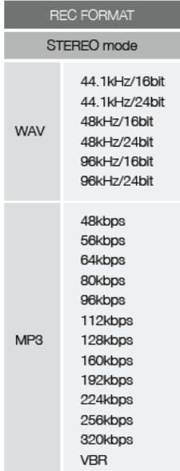
  - Rotate the DIAL to select between STEREO, 4CH, and MTR mode.
  - Once the selection’s been made, press MEMU to confirm and return to other options.

- Setting Recording Format: WAV, MP3, sampling frequency, bit rate (Note: Improving the sound quality increases the song size and decreases the recording time. When making a final recording of a performance, it is best to use WAV 16 bit or 24 bit to give priority to sound quality.)
- Press MENU and rotate the DIAL to select REC.
- Press down DIAL to enter REC SETTING.
- First option is REC FORMAT. Press down DIAL to enter REC FORMAT options.
- Rotate the DIAL to select your desired format. (Note: For audition music CD quality, WAV44.1kHz/24bit is recommended. To sync your audio file with your video file for audition videos, choose WAV48kHz/16bit. )
- Press down DIAL to confirm your selection and go back to previous menu option.

- Choosing Option Settings:
  - LOW CUT: The <LO CUT> filter setting allows you to eliminate wind or blowing noises, or any unwanted low-frequency signal components.
- Press MENU and rotate the DIAL to select INPUT.
- Press down DIAL to enter INPUT SETTING.
- Press down DIAL to enter LO CUT (LOW CUT) option screen.
- Set MIC to OFF if no external microphone is used.
- INPUT set to OFF for interview or meetings in a quiet situation. To record music performance, select the cutoff frequency based on the lowest frequency of your input sound. The smaller the number, the lower the cut-off frequency.

  - COMP/LIMIT: The <COMPL/LIMIT> setting can compensate for volume differences. For each input source, low level input signals are lifted up and high level input signals are controlled down when recording.
- Press MENU and rotate the DIAL to select INPUT.
- Press down DIAL to enter INPUT SETTING.
- Rotate the DIAL to select COMP/LIMIT and press down.
- Refer to the following table to select the setting input source and the setting target.
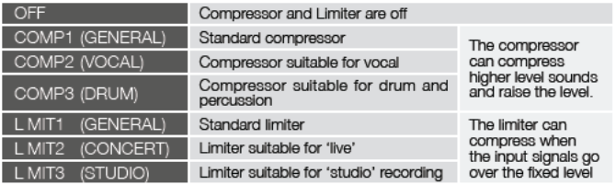

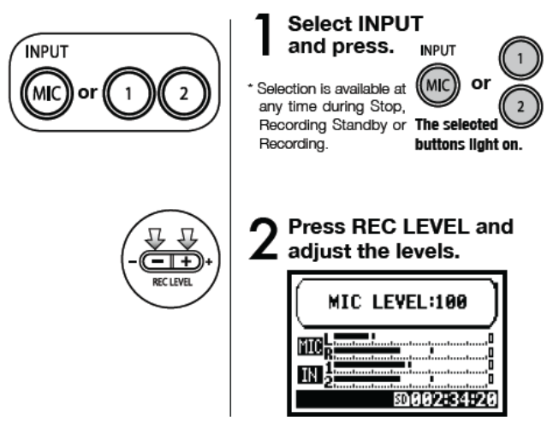
  - LEVEL AUTO:
  - When it is set to ON, the recorder automatically sets the recording level.
  - When it is set to OFF, user must manually adjust the recording level prior to recording.
Note: For music recording, set to OFF is recommended. Refer to the steps on the left to adjust your recording level in order to get best sound quality.

To view the audio meter, you can press REC button once to enter RECORD STANDY mode (back red light blinks). While playing the loudest part of your music, watch the audio meter and adjust the recording level accordingly by pressing REC LEVEL selectors located on the right side of the recorder. The good rule of thumb is to set the recording level between -12 and 0db. Clipping happens beyond 0db.

- Reading Recorder Screen:

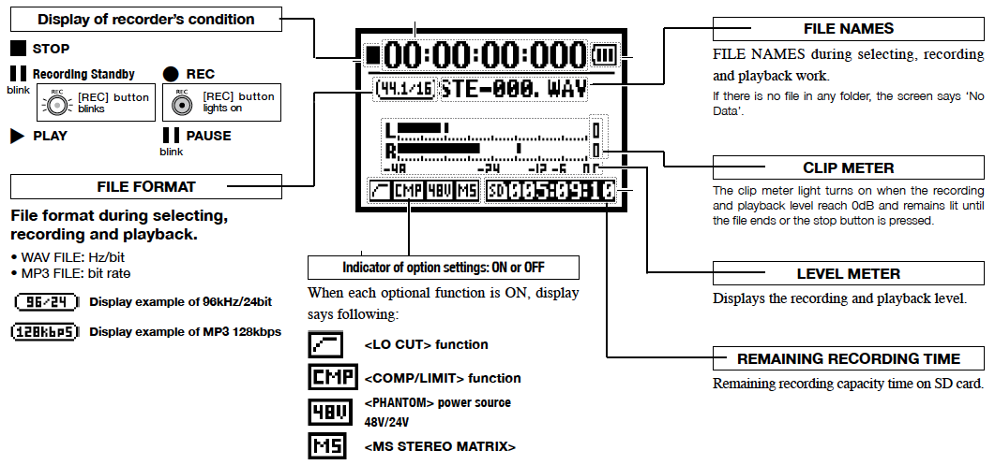

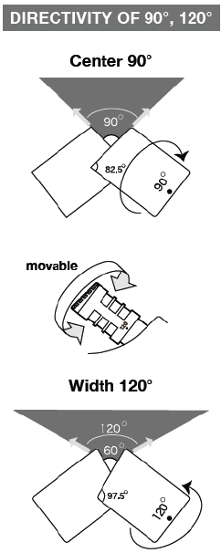
- Setting Up Built-in Microphones: The Zoom H4n has high quality microphones in an XY pattern which ensure a natural stereo image when recording sounds. By placing two microphones in a crossed pattern (opposing angles), the H4n can cover a wide area and capture sound sources in the center with clarity and definition. Sounds reach both mics simultaneously, and therefore no phase cancellation occurs between right and left channels. Refer to the images on the left to adjust microphone’s directivity of 90°, 120°.

- Downloading Files:
  - Connect recorder to computer via USB cable.
  - Turn on the power.
  - The screen shows STORAGE, AUDIO I/F. Press down DIAL on the right side to confirm STORAGE connection type.
  - USB STORAGE shows up on the screen and the audio recorder disk is mounted on your computer desktop meaning connection is completed.
  - Refer to FILE SAVING PLACE under Overview of Zoom H4n on page 2 to locate your files.
  - Simply drag and drop the files to transfer your recordings to the computer.

- Using Stamina Mode: Stamina switch is located in battery compartment on the back of recorder. When switch ON, you are recording in Stamina Mode. This mode allows for longer battery life (continuous recording up to 11 hours), but can only record/playback in WAV 44.1 kHz/16-bit and MP3 format. If you find no way to adjust your recording format and mode, check the STAMINA switch in battery compartment and make sure to switch OFF. After STAMINA Mode is turned OFF, you can access to more settings under MENU.

- Reference:
  - Zoom H4n User Manual.
  - http://www.zoom.co.jp/products/h4n/
  - http://youtu.be/iUf-a1Yyxnc

