- What are the three main purposes of a dashboard?
  - Inform the audience of a data story
  - Explore relationships within the data
  - Monitor the changes that may occur in data
- Live data connection vs Extract data connection
  - Live data connection
    - Refreshes automatically
    - Processes queries in the source database
  - Extract data connection
    - Uses Tableau data engine to perform queries
    - May include only a subset of the data
    - Can be accessed offline
- In order to blend data from two data sources, the data sources need a common DIMENSION.
  - One primary data source, the first one added, a blue check mark in data pane.
  - A secondary data source, an orange check mark
  - It is kind of left-join, it returns all data from primary table, and only matching data from secondary table.
  - Data blending is Tableau worksheet specific
  - If you want your results to include all values from the Visitors data source, you should make it the PRIMARY data source.
- When using blended fields in a calculation, what must you do to all data source fields?
  - Aggregate them
- Joins with multiple matches
  - This results in duplicated data
  - A left join may result in more rows in the joined data source.
- Data blending is very similar to a left join, but does not duplicate data when there are multiple matches on the linking field
  - Blending combines all rows in the primary data source with matches on the linking field from the secondary data source. Unlike a LEFT JOIN multiple matches on the linking field do not result in duplication of values.
  - All the rows from the primary table will be kept, the number of the rows in the primary will be kept, no more rows added or removed.
  - Primary - secondary
    - 1-1
    - Multiple to 1, only the first row of the multiple will get value from the secondary table
    - 1-multiple, asterisk * will be placed in the primary table cell.
ATTR
ATTR(expression)
Returns the value of the expression if it has a single value for all rows. Otherwise returns an asterisk. Null values are ignored.
    - 1-nothing, null will be placed in the primary table cell
    - Blend your data https://onlinehelp.tableau.com/current/pro/desktop/en-us/multiple_connections.htm

- Union combines multiple tables from the same data source. Union lengthens the table, while joins widens the table.
- Filter across data sources
  - Verify the required relationship between fields
  - Create the filter
  - Apply the filter across related data sources.
- Combined sets: allow you to compare multiple sets to one another
- In/Out sets: used to compare members in a set to members out of a set
- You can’t join on split field, but you can blend on split fields. You can use it in any part of the view. Split field is a calculated field.
- Dimensions can be aggregated too.
  - When you blend multiple data sources, in which dimensions don’t have consistent LOD (level of detail). Tableau will aggregate the linked dimension to the same level of detail.
  - You may need to aggregate dimensions in calculations. When dimensions are used in calculation with aggregated measures, dimensions need to be aggregated. Tableau cannot mix aggregate and non-aggregate comparisons in calculations.
  - You just want to know the aggregation of the dimension.
- Types of aggregations that can be applied to dimensions
  - Right click (windows) and drag a dimension to Rows or Columns or Option + click and drag
  - Min, Max, Count, CountD, Attr
  - Count returns the total number of entries, while CountD returns the total number of unique entries.
  - Attribute returns the value of an given expression if the entry has a single value, * if multiple values. It is similar to Min, and Max. e.g. ATTR([Market])
- Table calculations
  - Scope
  - Direction
  - Null values, it depends on the calculation. Running total skip over null values, nulls are treated as zeros
  - Order of calculations
    - Extract filters
    - Data source filters
    - Context filters
    - measure/dimension filters
    - Table calculations
    - Table calculation filters
  - Table (across then down)
    - Total the first row, then add the next row to those values, resulting the greatest values being in the bottom row.
    - 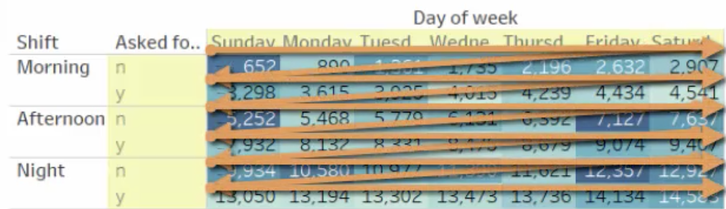
    - Table (down then across)
    - 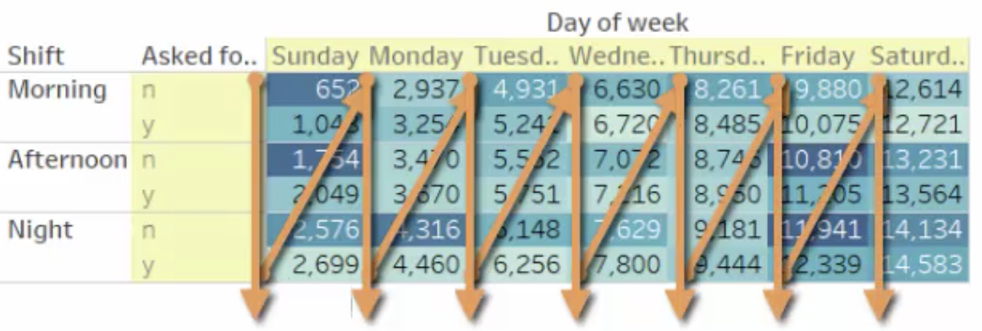
- When creating charts and crosstabs in Tableau, the view is gradually built by what you place on rows and columns. This placement determines the level of detail you’re able to see in your worksheet view. This is a powerful tool, but what if you wanted to use a dimension you haven’t placed in the view? Level of detail expressions allow you to create calculations that exist at different levels of detail than what is shown in the view.
- Table calculations are context sensitive, while LOD calculations are not context sensitive.
- Tableau order of operations https://onlinehelp.tableau.com/current/pro/desktop/en-us/order_of_operations.htm
- Applying a parameters
  - Make it
  - Use it
  - Show it
- Why is it helpful to give a parameter an actionable title? - The title can tell someone how to use the parameter control.
- Dynamic measure selection
- diff between sum(measure) and agg(measure)
  - AGG() simply indicates an aggregation within a calculated field.
For instance, if you drag a Sales pill out into a view, by default, Tableau will wrap it in SUM(), and you can change the aggregation. However, if you were to write a calculated field of SUM(Sales), and pull that into the view, it would appear as AGG([NameOfCalculatedField]).
  - Aggregate Functions in Tableau https://onlinehelp.tableau.com/current/pro/desktop/en-us/calculations_calculatedfields_aggregate_create.htm
- Location error “ambiguous” means “more than one place has that name. To fix it, adjust the geographic role or the matching location”.
- Custom geocoding is necessary when you need user defined locations to map your data.
- In order to find an X and Y coordinate on your background image, you would “annotate a point”.
- In Tableau, a bin is a “range” of values.
  - A bin includes numbers/values equal to or greater than lower limit, but not include the lower limit of next bin
- Box and Whiskers Plot:
  - Help us compare distributions and outliers
  - The rectangle is the box, and the two lines that are extending to it are the whiskers
  - The center of the box lies in the middle of the distribution, at the median
  - The box includes half of the data points
  - The upper and lower of the box show the upper and lower quartiles, one quarter is above the box, one quarter is below the box.
  - IQR, interquartile range is the height of the box, is the range of the box
  - Upper and lower whiskers are not always the same length, the whiskers will show the last data point within 1.5 IQR, which is not always the same from the median above and below
  - “To highlight individual outliers”, to set the whiskers to extend the data to 1.5 times of the IQR.
  - To find the Median, place the numbers in value order and find the middle number. Example: find the Median of {13, 23, 11, 16, 15, 10, 26}. The middle number is 15, so the median is 15. (When there are two middle numbers we average them.)
- Measure names and measure values
  - Measure names Is a dimension that contains all the labels of each measure in the data source
  - Measure values is a measure that contains numeric values for each measure
- Bar in bar chart
  - Turn off “stacked bar” from menu->Anaylysis->Stack Marks->off, to make both bars start at 0
  - Are useful to compare two measures as overlapping bars in the same space. It is helpful to make the bars different sizes so you don’t end up with some of the bars hidden underneath of the others
- Bullet graph
  - Is good to show stage progression towards the goal
  - Is most useful to compare two measures
- Showing Statistics and Forecasting:
  - Use the Analytics Pane and Trend Lines
Make your visualizations more meaningful by adding trend lines or forecasting! Learn how to add trend lines and what they might mean for your data. Use forecasting to estimate future data trends and help your audience make better decisions.
- Trend line
  - To explore the relationship between two measures, to find out correlations between measures
  - Trend line by default is per pane
    - The bold line - is the actual trend line
    - The lighter lines - display the confidence band, 95% interval
  - Describe Trend Model
    - High level description of trend model including fields that are factors of the model
    - Second part - highlight statistical details describing the trend line
    - Last section - it is the description of model details for each trend line in the view
    - R-squared - how well the trend fits the data. 1 or 100% means a perfect fit
    - P value - is a probability value associated with significance. Smaller P-values are better. Usually we look for <0.05
- Forecasting
  - Is a way to estimate future values based on continuous historic data. Tableau provides built-in statistical models to forecast your data including models that account for seasonality and trends
  - To build a forecast, you need
    - One continuous date
    - One measure and 5 data points
    - Also if you data contains seasonal time, then you need at least two seasons
  - Describe forecast
  - Forecast options
  - The shade region in the Forecast is called prediction interval
  - Exponential smoothing
- Dashboard
  - An effective dashboard has
    - A clear purpose
    - Is relevant to its intended audience
    - And shows its users how to interact with data
  - Four steps to create an effective/successful dashboard
    - Determine its purpose and audience
    - Plan the dashboard thoroughly
    - Build using best design practices
    - Test it for usability and performance
- Dashboard - serve to put the focus on the data and give ease for people who seek answers from data.
  - Instructions - clear instructions
  - Tooltip - needs clarity, helpfulness, and consistency, context
    - Add a dynamic field to show and update information on that field
  - Contrasting colors - colors help interpret the data, but not distract from data
    - Use color to salient and posing data, keep color muted for everything else, so it doesn’t distract from data, keep the dashboard color range minimum
    - To limit the number of colors you use
    - Change the color of Marks from the color mark card in the worksheet
  - Arrangement - a helpful arrangement of parts
  - Fonts - consistent and useful font formatting
    - Font formatting is appropriate and consistent for titles, instructions, headers, labels, and text in filters and legends
- Advanced filters
- Stories
  - Tableau story is a connected series of worksheets and dashboards that allow you to capture insights and share them in sequential presentation.
  - A story contains one or more story points
  - Dashboard supports data exploration and questions, whereas a story point is to share data insights to tell a data story. Changes in story points don’t track back to worksheet.
  - You can enhance your story using annotations and descriptions.
  - Tableau stories consist one or more stories that can be rearranged in any order.
  - Title in worksheet doesn’t get carried over to the story, you can remedy this by adding descriptions.
  - Titles in dashboard will be carried over to story.
  - Local settings override the global settings
  - To format story, from menu, Story-> format, or Format -> story.

