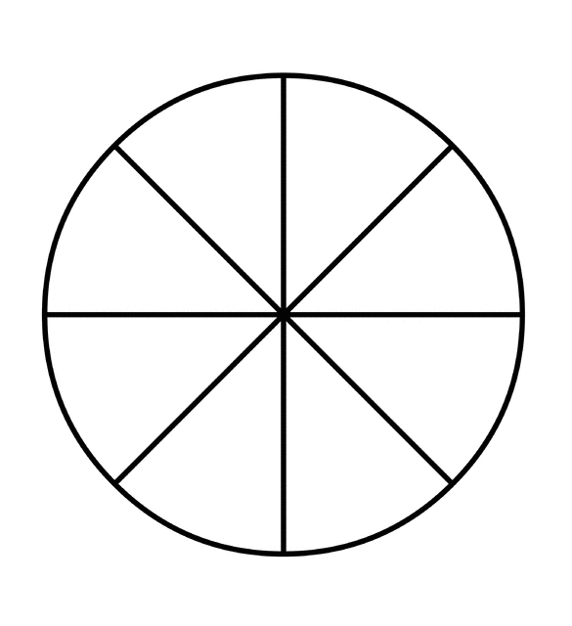
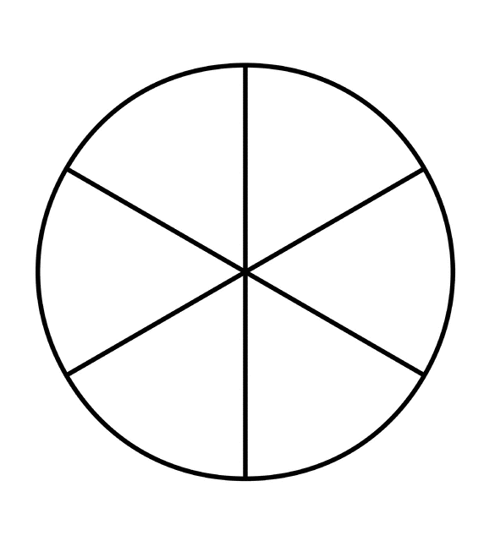
–Shyam Bhakta
$$\frac{1}{2} \frac{1}{4} \frac{1}{8} \frac{1}{12}$$
$$\frac{1}{2} \frac{1}{3} \frac{1}{6} \frac{1}{9} \frac{1}{18}$$

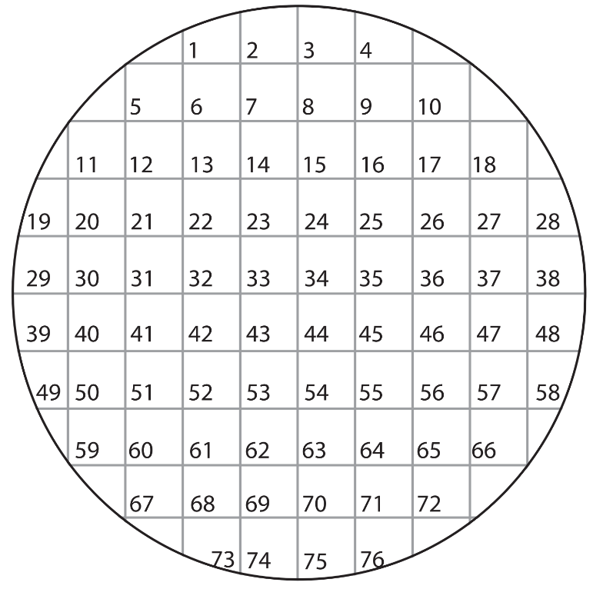

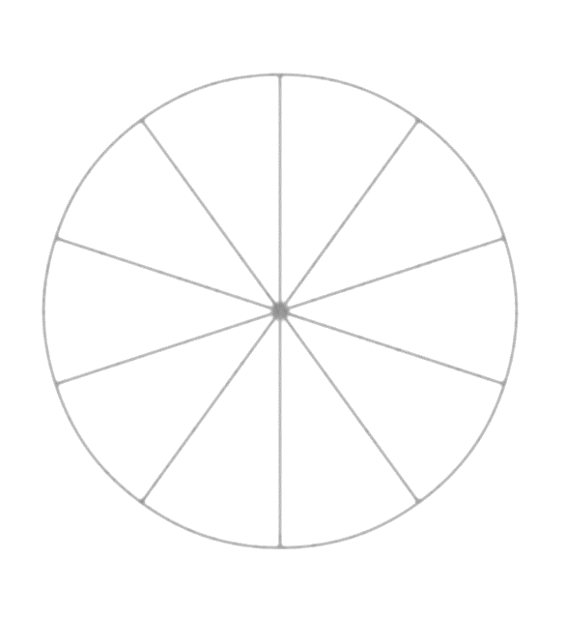
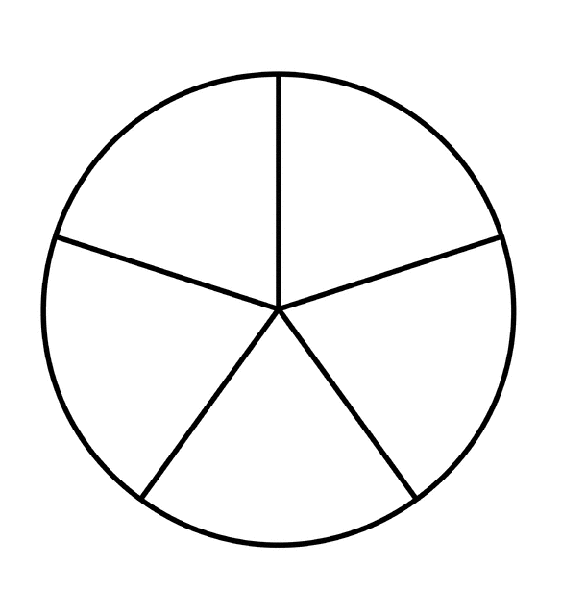
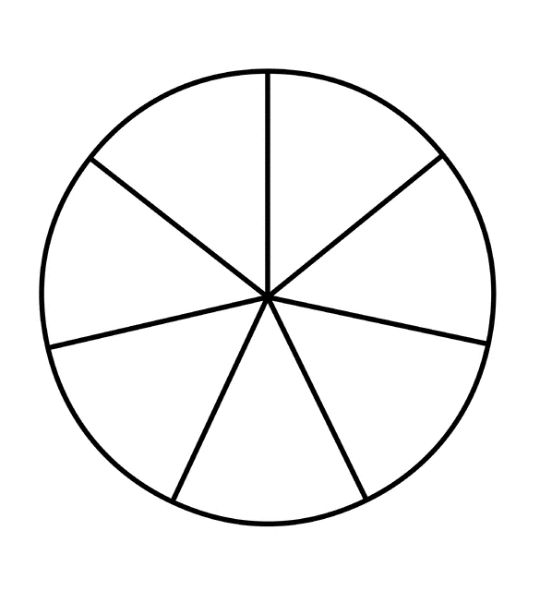
$$\frac{1}{5} \frac{1}{10} \frac{1}{15}$$
$$\frac{1}{7} \frac{1}{14}$$

$$\frac{1}{9} \frac{1}{16}\frac{1}{24} \frac{1}{28} \frac{1}{32}$$
$$\frac{1}{20}$$
$$\frac{1}{16}$$
–Shyam Bhakta

